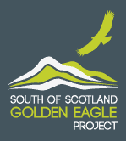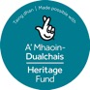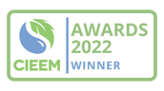

**Media release**

**Immediate release**

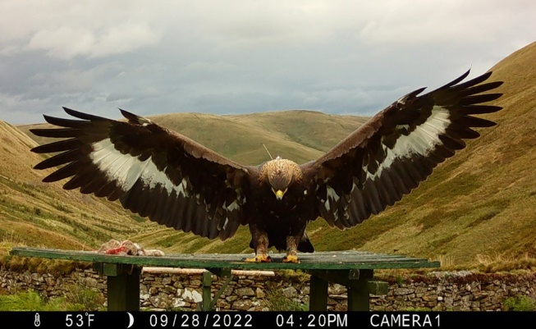**Pioneering project responds to disappearance of Merrick the golden eagle**

Representatives for a groundbreaking conservation initiative, which attributes its success to overwhelming support from the public, raptor workers and land managers, have today expressed their shock, sadness and disappointment at the disappearance of Merrick, a female golden eagle translocated by the project in 2022. Police Scotland today confirmed they “believe the bird has come to harm and are treating its disappearance as suspicious.”

Responding to the news and backing calls for anyone with any information to report it to Police Scotland, Chair of the South of Scotland Golden Eagle Project, Dumfriesshire farmer Michael Clarke said: “The disappearance of any golden eagle is extremely upsetting, but particularly when there is evidence to suggest that they have come to harm under suspicious circumstances. The project’s translocated eagles have captured the hearts and minds of many people, including children, who will all share in our utter shock, disappointment and sadness at the nature of Merrick’s disappearance.

“Indeed, the huge support our project has had for many years from tens of thousands of people in the community, raptor workers, conservation and the land management sectors, makes it all the more devastating makes it all the more devastating to learn that she may have come to harm at the hands of someone who has disregarded the legal protection of the bird and the vital importance of a restored golden eagle population to protecting biodiversity and reversing nature’s decline.  
  
 “The South of Scotland Golden Eagle Project’s success in quadrupling the local population is absolutely testament to the overwhelming community support, faith and trust that we have had in our work to date. For over six years our passionate and dedicated project team have worked painstakingly round the clock, in partnership with raptor workers, vets, estates, land managers, game keepers and the wider community, to ensure the health and safety of the birds we translocate. Continued support such as this is vital to saving Scotland’s nature for future generations.

“We are more resolved than ever to do our supporters justice and ensure the golden eagle population in the south of Scotland continues to thrive.

“We’re grateful to Police Scotland for support and using all the resources at their disposal to establish the full circumstances. To ensure due process is followed, we cannot comment further at this stage. We will do so when Police Scotland shares more detail.

“We thank everyone for their support at this tough time and urge anyone with information to assist Police Scotland by contacting them on 101, quoting incident number 1193 of 18 October 2023.”

Merrick (F43), named after the highest peak in the Southern Uplands, originated from Rottal estate near Kirriemuir in the Angus Glens, a traditional sporting estate, which is accredited by Wildlife Estates Scotland (WES) for its commitment to protecting and restoring wildlife and biodiversity.

Merrick was the fifth eagle collected in the summer of 2022, the last to leave the aviaries, and the heaviest eagle translocated that summer at 5.2 kg. She was named by the South of Scotland Golden Eagle Project’s host charity, the Southern Uplands Partnership (SUP).

Before her disappearance, the South of Scotland Golden Eagle Project team’s round-the-clock surveillance of the golden eagles, showed that Merrick was thriving and exploring all over south of Scotland and Northern England in the south of Scotland. Merrick was photographed on her trip in Weardale and filmed in Nidderdale Area of Outstanding Natural Beauty.

The South of Scotland Golden Eagle Project partners the Southern Uplands Partnership, RSPB Scotland, Scottish Land & Estates, Scottish Forestry and NatureScot all share in the disappointment of today’s news. They worked on the project together for more than 11 years before releasing the first eagle chicks in 2018. Funded by The National Lottery Heritage Fund, project partners and the Scottish Government, the initiative is a key project under the Government’s ‘Challenge for Scotland’s Biodiversity’.

For more information or to donate to the charity initiative, visit: [www.goldeneaglessouthofscotland.co.uk](http://www.goldeneaglessouthofscotland.co.uk)

**Ends**

For more media information contact Kirsty Innes, email [kirsty@kirstyinnespr.com](mailto:kirsty@kirstyinnespr.com), tel 07790 910 646.

**Notes to Editors**

**About the South of Scotland Golden Eagles Project**

* Before the project began, there was only between two and four pairs of golden eagles across Dumfries and Galloway and the Scottish Borders, however a supporting study by NatureScot shows that the local habitat is suitable for up to 16 pairs.
* Earlier this year, the project was awarded the prestigious Chartered Institute of Ecology and Environmental Management (CIEEM) Tony Bradshaw Award for Outstanding Best Practice.
* Since 2018, the South of Scotland Golden Eagle Project has successfully translocated 32 golden eagles, bringing the total population of golden eagles in the south to around 46 – more than quadrupling the population to the highest number recorded in the area for three centuries.
* Most of the birds quickly settled into their new habitats, fending for themselves.
* During the first Covid-19 lockdown in 2020, Beaky was the first of the project’s eagles to venture south of the border and visit the North Pennines area, where there have been no breeding pairs of eagles for many years. She was also later seen demonstrating potential courtship behaviour with Skan, one of the male eagles translocated to the area by the project.
* The project has identified that the best way of enhancing this fragmented and vulnerable population of golden eagles is through increasing the supply of young eagles, which will eventually recruit into the breeding population.
* Recent satellite tagging work of golden eagles in Scotland has shown that the south of Scotland golden eagle population is greatly isolated from larger populations of this species from the Highlands.
* For the next two years, the Project will continue to translocate juvenile and subadult golden eagles under the conditions of the novel research licence.
* For the translocations featured in this news story, the project team:
  + Used tried and tested methods for rear and release of the young golden eagles derived from previous white-tailed eagle and red kite reintroduction projects, and through the cooperation of raptor experts and estates.
  + collected single eagle chicks from broods of young in the Highlands and raised and released them in an undisclosed location in the southern uplands.
  + focussed on ensuring former and potential nesting sites are re-occupied; to identify any additional habitat management measures that will bring further improvements in food supplies in these areas; and wider work with local communities, schools, and enterprises to bring much wider benefits.
* Each released golden eagle is satellite tagged by licensed individuals to ensure the project team builds up as much information as they can on the ranging behaviour, survival, and health of the birds.
* Project staff work a variety of expert advisers, including specialists from the Edinburgh University Dick Vet School, and from Ireland and Spain who have been heavily involved in successful raptor reintroduction programmes.
* Over 15,000 volunteers and special project participants of all ages (aged 4 to 92) have taken the golden eagles under their wings, as they’ve supported the project through a wide range of tasks and initiatives.
* In September 2021, the project worked with Visit Moffat to host the UK’s first ever golden eagle festival to celebrate the town of Moffat becoming the country’s first official Eagle Town. The programme included a keynote speech from Gordon Buchanan.
* In May 2021, the project opened the UK mainland’s first ever golden eagle information point. Designed by award-winning exhibition designers Studioarc, in partnership with the project team, the new Eyrie: Eagle Information Point is located in the new Waterwheel Tearoom in Philiphaugh Estate, near Selkirk.
* Those who have participated in the initiative to date come from a range of backgrounds and organisations, including: the UK’s first ever Golden Eagle Scout Champions at the Scottish Borders Scouts; over 360 pupils from primary schools across the south of Scotland and one in the Scottish Highlands; Borders College; the Scottish Raptor Study Group; Kielder Bird of Prey Centre; HMP Dumfries; and local businesses like Wild Tree Adventures.
* The South of Scotland Golden Eagle Project is:
  + supported by Scottish Land & Estates, RSPB Scotland, Scottish Forestry, NatureScot, and The Southern Uplands Partnership.
  + funded by:
    - £1.5 million from The National Lottery Heritage Fund;
    - the Scottish Government; and
    - Scottish Power Renewables.
  + licenced to undertake the work by NatureScot (formerly Scottish Natural Heritage).
* The project also previously received more than £150,000 match funding from the Scottish Government and the European Union – LEADER 2014-2020 programme.
* The Project’s Scientific Advisory Panel provides the project with expert scientific, veterinary and technical advice (particularly to ensure eagle health and welfare). Members also advise on wider specific scientific and land management/land use issues. Members include:
  + Dr Neil Anderson (Chair), The Royal (Dick) School of Veterinary Studies, University of Edinburgh
  + Professor Rob Ogden (Deputy Chair), The Royal (Dick) School of Veterinary Studies and The Roslin Institute, University of Edinburgh, and NatureScot Scientific Expert panel
  + Dave Anderson, Scottish Raptor Study Group
  + Roy Dennis MBE, Roy Dennis Wildlife Foundation
  + Professor Miguel Ferrer, Spanish National Research Council
  + Dr Alan Fielding, NatureScot Scientific Expert Panel
  + Dr Gidona Goodman, The Royal (Dick) School of Veterinary Studies, University of Edinburgh
  + Professor Anna Meredith OBE FRCVS, The Royal (Dick) School of Veterinary Studies, University of Edinburgh
  + Stephen Murphy, Natural England
  + Professor Ian Newton OBE FRS FRSE
  + Lorcan O’Toole, Golden Eagle Trust Ireland
  + Professor Chris Quine FRSE Forest Research
  + Chris Rollie, RSPB and Scottish Raptor Study Group
  + Dr Ewan Weston, Scottish Raptor Study Group
  + Dr Phil Whitfield, Natural Research
  + Ray Lowden, Falconer, Kielder Bird of Prey Centre
  + Dougie McKenna, Senior Ecologist and Falconer, Stones Wildlife Management
  + Robin Reid, Scottish Raptor Study Group
* Using money raised by the National Lottery, The National Lottery Heritage Fund **inspires, leads** and **resources** the UK’s heritage to create **positive and lasting change** for people and communities, now and in the future. [www.HeritageFund.org.uk](http://www.heritagefund.org.uk/).
* Follow @HeritageFundUK on [Twitter](https://twitter.com/HeritageFundUK), [Facebook](https://www.facebook.com/HeritageFundUK) and [Instagram](https://www.instagram.com/heritagefunduk/) and use #NationalLotteryHeritageFund

